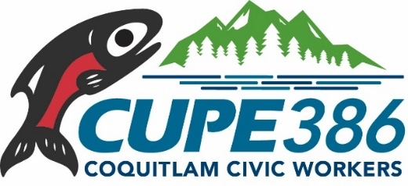
Notice of September General Membership Meeting
Date: Tuesday, September 19, 2023
Time: 5:15 pm
Location: Union office
101 – 1550 Hartley Avenue, Coquitlam
*Food and beverages will be provided*

Agenda items will include:
Minutes of the June 2023 General Membership Meeting
Treasurer’s Report for June, July and August 2023
Correspondence and Bills
Committee Reports
- President
- Shop Stewards
- Negotiations/Bargaining
- Education
- Occupational Health & Safety
- Political Action
- Other
Unfinished Business
New Business
Good of the Union

